**CS571: Artificial Intelligence Lab**

Indian Institute of Technology Patna

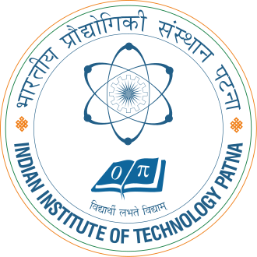

# **ASSIGNMENT 10**

Neural Networks

**Group Members**

* Kartik Mouli (2001CS35)
* Rohit Ranjan (2001CS56)
* Siddhant Kumar (2001CS70)